DoctorDayPlan v1.0
Project Scope
In Scope
DoctorDayPlan v1.0 is a doctor-centric practice management platform designed for independent doctors operating one or more clinics. The application aims to digitize the daily workflow of a doctor's practice by replacing manual appointment registers, paper prescriptions, and dependency on front-desk staff for routine scheduling tasks.
The system provides two user roles:
- Doctor (Primary User)
- Patient (Secondary User)

1. User Requirements
These describe what each user expects from the system.
Doctor Requirements
- The doctor shall be able to securely log in to the system.
- The doctor shall be able to manage their professional profile.
- The doctor shall be able to manage multiple clinic locations.
- The doctor shall be able to configure working schedules and availability.
- The doctor shall be able to view and manage appointment requests.
- The doctor shall be able to manage the live consultation queue.
- The doctor shall be able to record consultation details and prescriptions.
- The doctor shall be able to access complete patient medical histories.
- The doctor shall be able to search patient records.
- The doctor shall be able to monitor daily appointments through a dashboard.
Patient Requirements
- The patient shall be able to register and log in securely.
- The patient shall be able to view doctor profiles and clinic availability.
- The patient shall be able to book appointments.
- The patient shall be able to track appointment status.
- The patient shall be able to check in for scheduled appointments.
- The patient shall be able to monitor their live queue position.
- The patient shall be able to access consultation history.
- The patient shall be able to download digital prescriptions.

Modules Specification
Module 1: Authentication & Access
Purpose:
Provides secure user authentication and authorization for both doctors and patients. This module acts as the entry point of the application and ensures that only authenticated users can access protected resources.
Responsibilities:
- Authenticate doctors and patients using JWT.
- Register new patient accounts.
- Securely store passwords using bcrypt hashing.
- Implement role-based access control (Doctor and Patient).
- Validate user identity before granting access to other modules.
- Allow authenticated users to manage their profile information.

Module 2 : Practice Management (Profile, Clinics & Scheduling)
Purpose:
Allows doctors to digitally set up and manage their medical practice, making appointment scheduling completely automated based on their availability.
Responsibilities:
- Create and update the doctor's professional profile.
- Manage one or more clinic locations.
- Configure weekly working schedules.
- Define consultation slot duration.
- Mark unavailable dates such as holidays or leave.
- Automatically generate available appointment slots.
- Allow patients to view clinic information and available slots.

Module 3: Appointment Management
Purpose:
Manages the complete lifecycle of appointments between patients and doctors, from booking until consultation.
Responsibilities:
- Allow patients to book appointments.
- Display available appointment slots.
- Allow patients to cancel appointments before confirmation.
- Allow patients to check in upon arrival.
- Enable doctors to accept, reject, or reschedule appointments.
- Display today's appointments to the doctor.
- Prevent duplicate bookings for the same time slot.
- Maintain appointment status throughout its lifecycle.

Module 4: Live Queue & Real-Time Updates
Purpose:
Maintains a real-time consultation queue that keeps both doctors and patients updated throughout the consultation process.
Responsibilities:
- Generate the live consultation queue from checked-in appointments.
- Display the current patient being consulted.
- Show queue position and estimated waiting time.
- Allow doctors to call the next patient.
- Allow doctors to skip patients when required.
- Remove patients from the queue after consultation.
- Synchronize queue updates instantly using Socket.io.
- Notify doctors and patients about important appointment events.

Module 5: Consultation & Medical Records
Purpose:
Provides a digital consultation workspace where doctors can maintain patient medical records and generate prescriptions.
Responsibilities:
- Display complete patient medical history.
- View previous diagnoses and prescribed medicines.
- Record new diagnoses and consultation notes.
- Add medicines and dosage instructions.
- Generate downloadable PDF prescriptions.
- Maintain a complete consultation history.
- Allow doctors to search patient records.
- Allow patients to access their medical history and prescriptions.

Technology Stack
Category | Technologies Used | Purpose
Frontend | React.js, React Router, Tailwind CSS, Axios | Develop the user interface, manage routing, API communication, responsive design, and real-time updates.
Backend | Node.js, Express.js, JWT, bcrypt . | Build REST APIs, handle authentication, password security, business logic, and real-time communication.
Database | MongoDB | Store and manage application data using a NoSQL database with object modeling.
PDF Generation | PDFKit | Generate downloadable digital prescriptions in PDF format.
Development Tools | Git, GitHub, Postman | Version control, source code management, API testing, and application development.
Deployment | Vercel, Render, MongoDB Atlas | Deploy the frontend, backend, and cloud-hosted database.

Use Case Diagram Module wise :

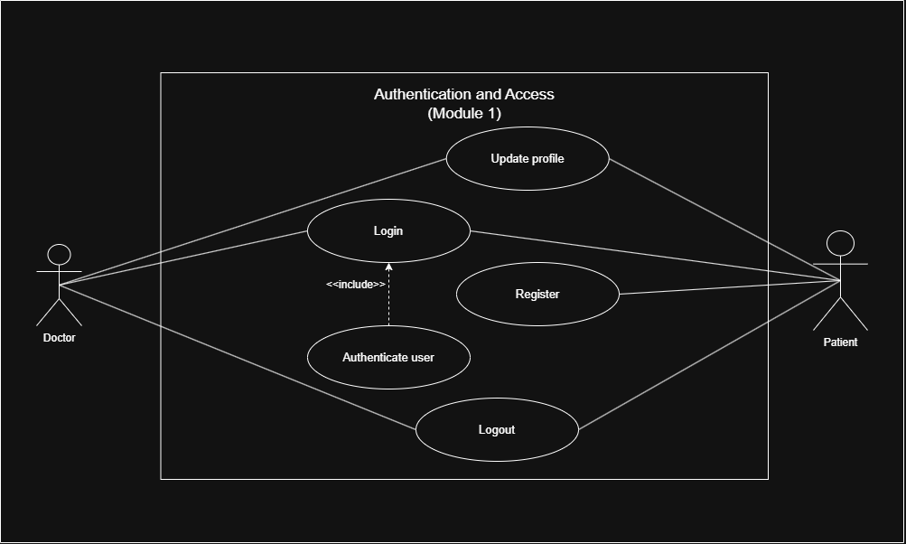

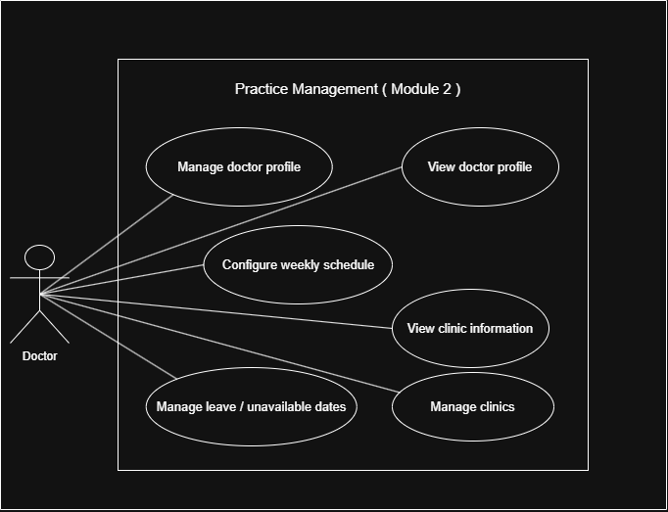

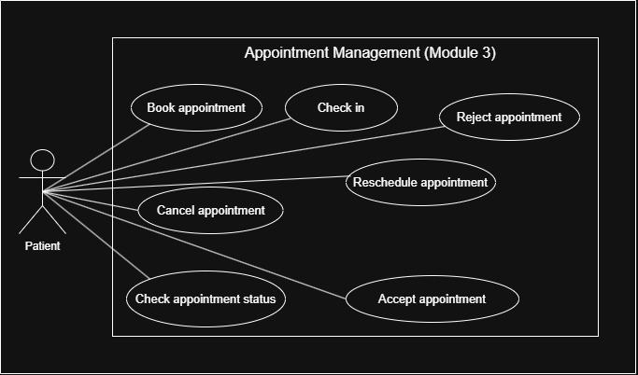

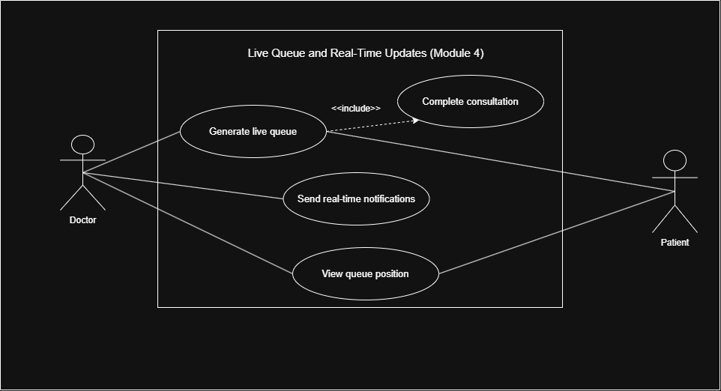

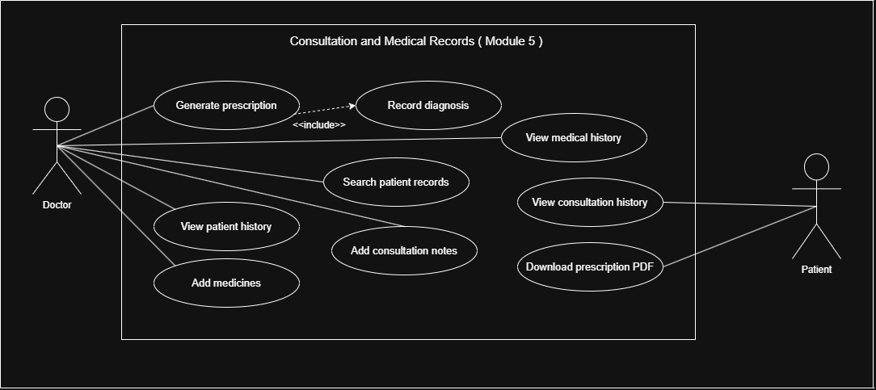

ER Diagram :
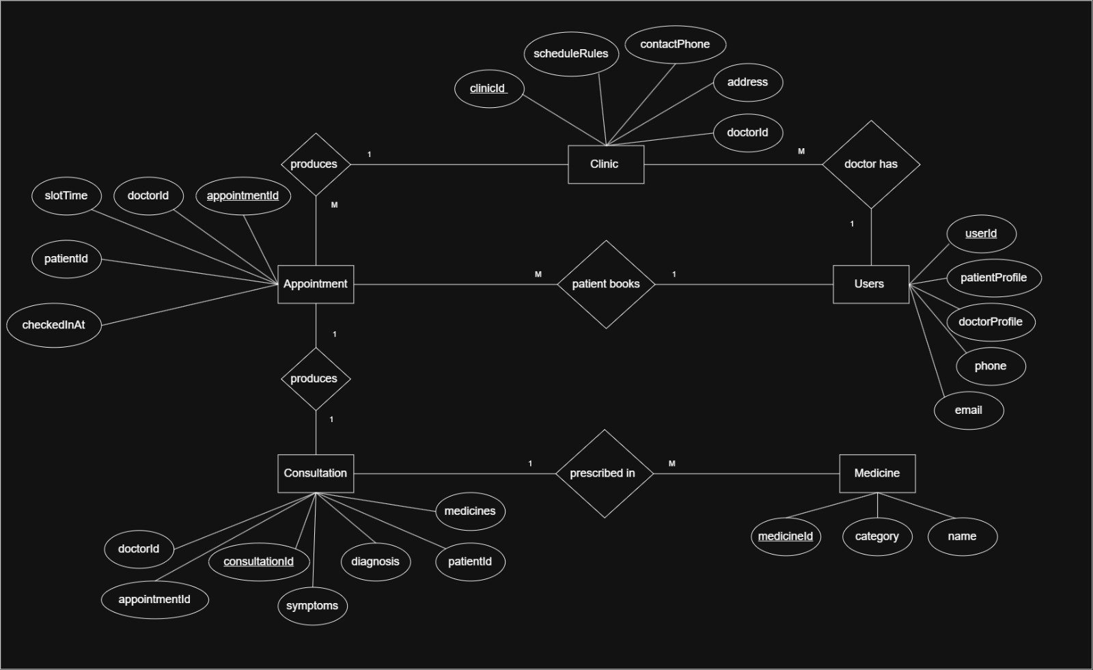

Data Dictionary

Collection 1: User
Purpose: Stores authentication and authorization information for both doctors and patients. Role-specific information is stored in embedded profile objects.
Field | Type | Required | Default | Description
userId (PK) | ObjectId | Yes | Auto-generated | Unique identifier for the user (maps to MongoDB _id)
email | String | Yes | — | Unique email address used for login
passwordHash | String | Yes | — | Password encrypted using bcrypt
role | Enum (doctor, patient) | Yes | — | Determines user role
phone | String | Yes (Patient) / No (Doctor) | — | Contact number
isActive | Boolean | Yes | true | Indicates whether the account is active
createdAt | Date | Auto | Current Timestamp | Record creation timestamp
updatedAt | Date | Auto | Current Timestamp | Last update timestamp
doctorProfile | Embedded Object | Conditional | — | Present only when role is doctor
patientProfile | Embedded Object | Conditional | — | Present only when role is patient

doctorProfile (Embedded)
Field | Type | Description
name | String | Doctor's full name
specialization | String | Medical specialization
qualification | String | Highest qualification
experienceYears | Number | Years of professional experience
bio | String | Professional biography
defaultSlotDurationMins | Number | Default appointment slot duration
avgConsultationMins | Number | Average consultation time
unavailableDates | Array | Leave dates with optional reason

patientProfile (Embedded)
Field | Type | Description
name | String | Patient's full name
dob | Date | Date of birth
gender | Enum | Male / Female / Other

Collection 2: Clinic
Purpose: Stores clinic locations and weekly schedules managed by the doctor.
Field | Type | Required | Default | Description
clinicId (PK) | ObjectId | Yes | Auto-generated | Unique clinic identifier
doctorId (FK → User.userId) | ObjectId | Yes | — | Doctor who owns the clinic
name | String | Yes | — | Clinic name
address | String | Yes | — | Clinic address
contactPhone | String | No | — | Clinic contact number
status | Enum (active,inactive) | Yes | active | Clinic availability
scheduleRules | Array | Yes | [] | Weekly schedule configuration
createdAt | Date | Auto | Current Timestamp | Record creation timestamp
updatedAt | Date | Auto | Current Timestamp | Last update timestamp

scheduleRules (Embedded)
Field | Type | Description
dayOfWeek | Number | 0–6 (Sunday–Saturday)
startTime | String | Start time (HH:mm)
endTime | String | End time (HH:mm)
slotDurationMins | Number | Appointment duration
bufferMins | Number | Gap between appointments

Collection 3: Appointment
Purpose: Stores all appointment requests and their lifecycle.
Field | Type | Required | Default | Description
appointmentId (PK) | ObjectId | Yes | Auto-generated | Unique appointment identifier
patientId (FK → User.userId) | ObjectId | Yes | — | Patient who booked the appointment
doctorId (FK → User.userId) | ObjectId | Yes | — | Doctor assigned to the appointment
clinicId (FK → Clinic.clinicId) | ObjectId | Yes | — | Clinic where appointment is scheduled
slotTime | Date | Yes | — | Appointment date and time
status | Enum | Yes | requested | Appointment status
symptoms | String | No | — | Symptoms entered during booking
checkedInAt | Date | No | — | Check-in timestamp
expiresAt | Date | Yes | Auto-generated | Request expiration time
rescheduleProposedBy | Enum | No | null | Doctor or Patient
proposedSlotTime | Date | No | — | Proposed rescheduled slot
statusHistory | Array | Yes | [] | History of status changes
createdAt | Date | Auto | Current Timestamp | Record creation timestamp
updatedAt | Date | Auto | Current Timestamp | Last update timestamp

statusHistory (Embedded)
Field | Type | Description
status | Enum | Appointment status
changedAt | Date | Timestamp
changedBy | ObjectId | User responsible for the change

Collection 4: Consultation
Purpose: Stores consultation details, diagnoses, medicines, and clinical notes.
Field | Type | Required | Default | Description
consultationId (PK) | ObjectId | Yes | Auto-generated | Unique consultation identifier
appointmentId (FK → Appointment.appointmentId) | ObjectId | Yes | — | Related appointment
patientId (FK → User.userId) | ObjectId | Yes | — | Patient being treated
doctorId (FK → User.userId) | ObjectId | Yes | — | Doctor conducting consultation
symptoms | String | No | — | Symptoms copied from appointment
diagnosis | String | Yes | — | Final diagnosis
medicines | Array | No | [] | Prescribed medicines
instructions | String | No | — | Patient instructions
notes | String | No | — | Consultation notes
createdAt | Date | Auto | Current Timestamp | Record creation timestamp
updatedAt | Date | Auto | Current Timestamp | Last update timestamp

Collection 5: Medicine
Purpose: Stores the master list of medicines available for prescriptions.
Field | Type | Required | Default | Description
medicineId (PK) | ObjectId | Yes | Auto-generated | Unique medicine identifier
name | String | Yes | — | Medicine name
category | String | No | — | Medicine category
createdAt | Date | Auto | Current Timestamp | Record creation timestamp

